**---------------------------------------------------**

**Smart Water Management.**

**----------------------------------------------------**

Sensors.

* Soil moister sensors .
* environmental sensor ,
* DIGITEN G1/2 Water Flow Hall Sensor Switch Flow Meter Flowmeter Counter

Definition:

* Soil moisture sensors are devices that measure the amount of water in the soil, providing essential data for agriculture and environmental monitoring.

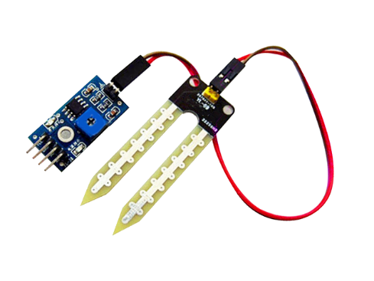

* Environmental sensors are devices designed to measure and monitor various physical parameters in the surrounding environment, such as temperature, humidity, air quality, light levels, and more.

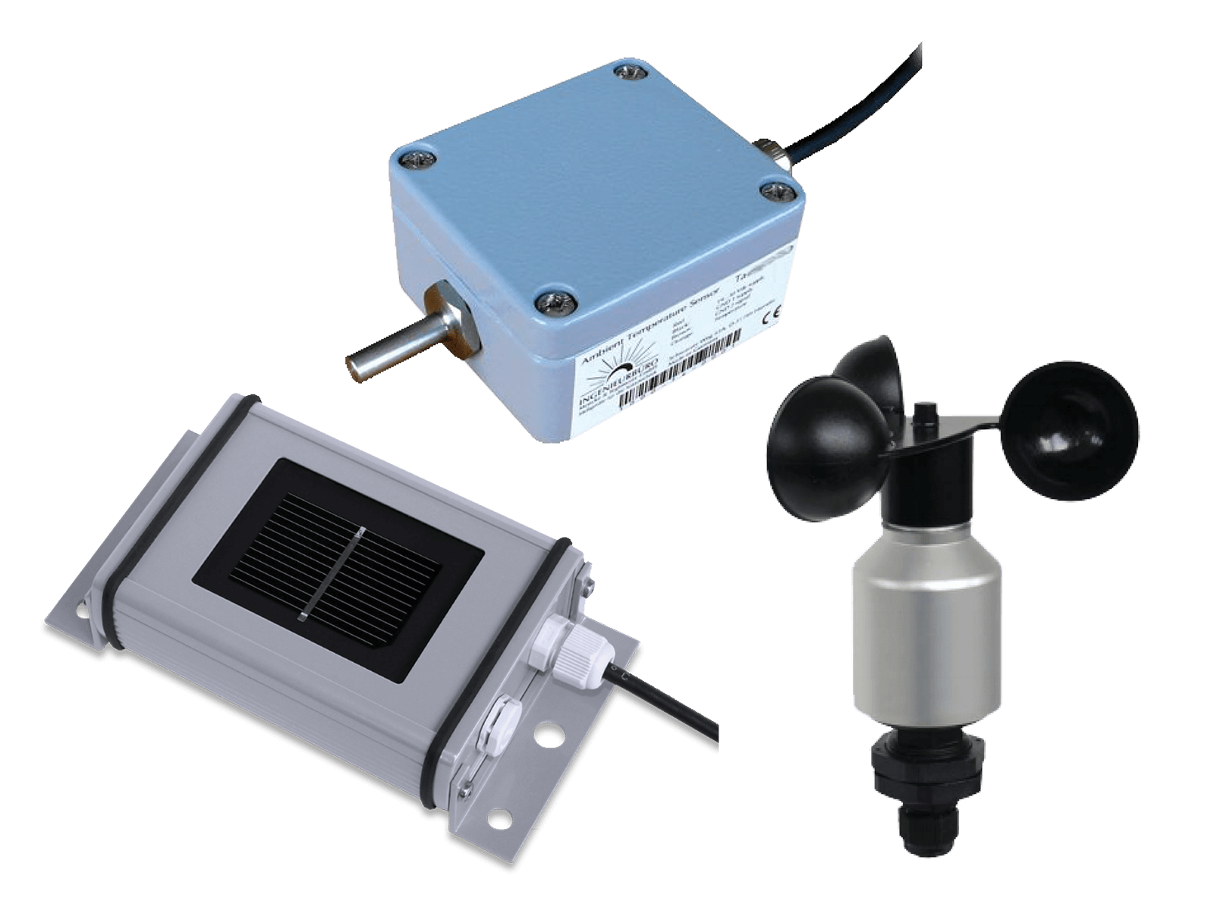

* The DIGITEN G1/2 Water Flow Hall Sensor Switch is a device used to measure the flow of water. It operates as a flow meter and includes a counter to keep track of the flow rate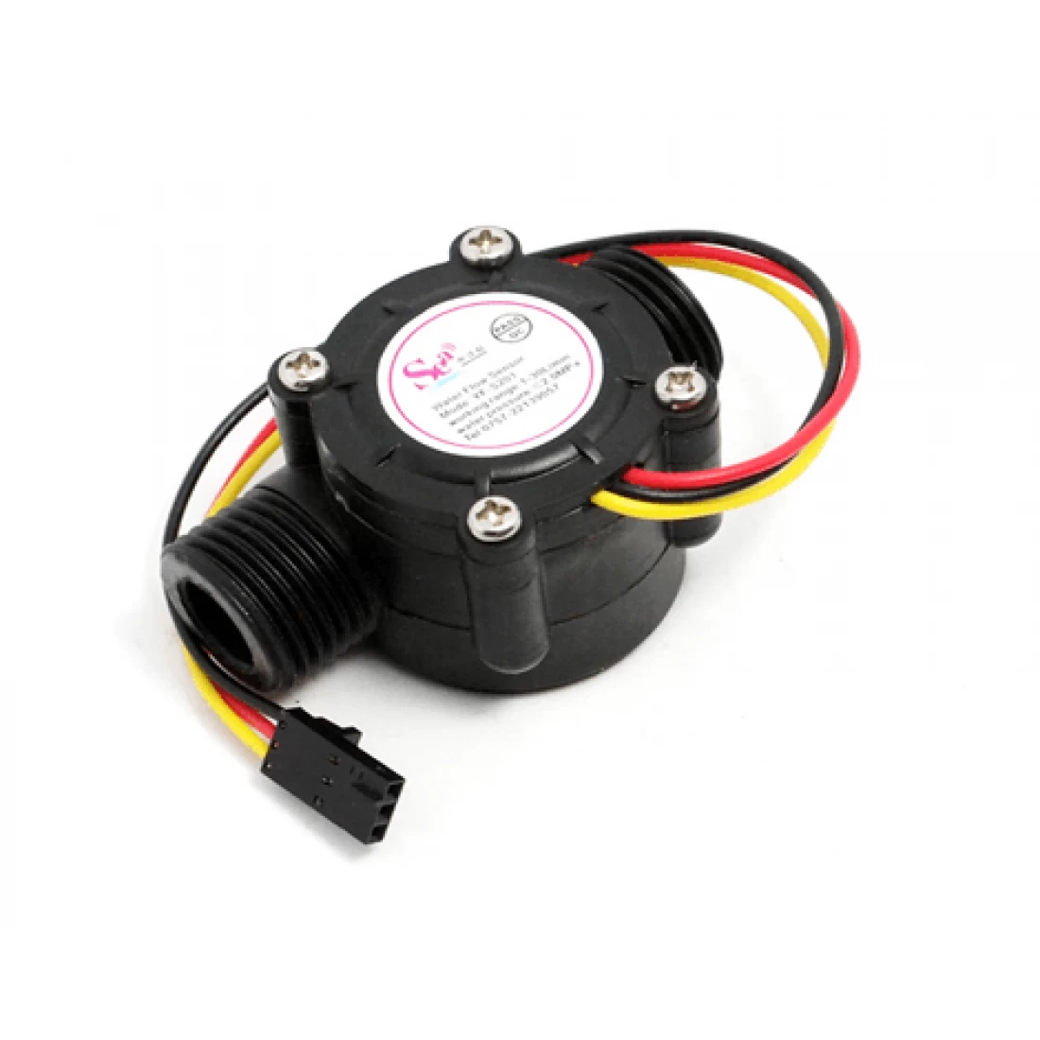

**BlockDiagram:**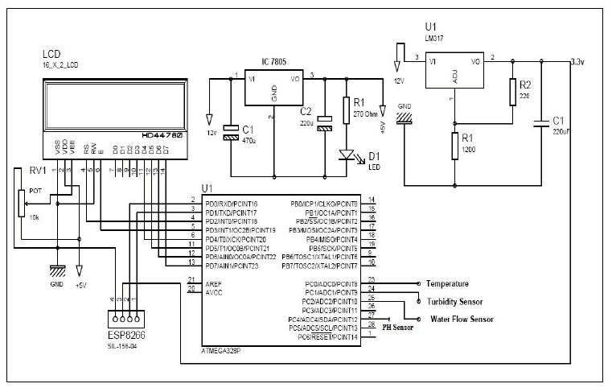

A short explanation of a smart water management system using IoT and an ESP32 processor block diagram is as follows:

* ESP32 Processor: The ESP32 is a powerful microcontroller with built-in Wi-Fi and Bluetooth capabilities, making it suitable for IoT applications. It serves as the central processing unit of the system.
* Sensors: Various sensors are connected to the ESP32, including water flow sensors, water level sensors, and possibly others like temperature or humidity sensors. These sensors collect data about the water system.
* Data Acquisition: The ESP32 gathers data from the sensors in real-time, such as water flow rates and water levels in tanks or pipelines.
* Local Processing: The ESP32 locally processes the collected data, making decisions or performing calculations if needed. For example, it can determine if there's a leak or send alerts when the water level is too low.
* IoT Connectivity: The ESP32 is connected to the Internet using Wi-Fi or other communication protocols. This allows it to transmit data to a remote server or cloud platform.
* Cloud Platform: Data from the ESP32 is sent to a cloud-based platform for storage and further analysis. This platform may use services like AWS, Azure, or Google Cloud.
* User Interface: Users can access the data and control the system through a web or mobile application. They can monitor water usage, receive alerts, and remotely control water-related devices.
* Remote Control: The user interface also enables remote control of devices such as water pumps or valves, allowing users to manage water resources efficiently.

Analytics and Reporting: The cloud platform can perform data analytics to identify patterns, trends, and anomalies in water usage. It generates reports and insights that can help in optimizing water management. Notifications and Alerts: The system can send notifications and alerts to users via email, SMS, or in-app notifications. For example, it can warn of potential leaks or excessive water consumption.In summary, this smart water management system utilizes IoT technology and an ESP32 processor to monitor and control water resources, ensuring efficient usage and providing valuable insights to users for better water management.

**working principle :**

Smart water management using IoT in an ESP32 processor works by connecting various water-related sensors and devices to an ESP32 microcontroller, which is then connected to the internet. Here's a short explanation of the working principle:

* Sensor Integration: Sensors such as water flow meters, water level sensors, and water quality sensors are connected to the ESP32. These sensors gather data about water consumption, water levels, and water quality.
* Data Collection: The ESP32 reads data from these sensors, collecting information on water usage, water quality parameters, and water levels.
* Data Processing: The collected data is processed locally on the ESP32. It can perform calculations, filtering, and data formatting as needed.
* IoT Connectivity: The ESP32 connects to the internet using Wi-Fi or other communication protocols like MQTT or HTTP. It establishes a connection with an IoT platform or cloud service.
* Data Transmission: Processed data is transmitted securely to the IoT platform or cloud server. This data can include real-time water consumption, water quality readings, and water level status.
* Data Storage: The IoT platform stores the received data in a database for historical analysis and real-time monitoring.
* Remote Access: Users can access the water management system through a web or mobile application. They can remotely monitor water usage, receive alerts for leaks or abnormal conditions, and set automation rules for water control.
* Analytics and Control: The IoT platform can provide insights through data analytics, helping users make informed decisions about water usage. Automated control systems can be set up to optimize water resources, such as turning off water when leaks are detected or adjusting irrigation based on weather forecasts.
* Alerts and Notifications: The system can send alerts and notifications to users' devices in case of critical events, like leaks, low water levels, or abnormal water quality.
* Efficiency and Sustainability: Smart water management using IoT on ESP32 aims to improve water efficiency, reduce wastage, and promote sustainability by providing real-time data and control options to users and organizations.
* In summary, this system enables efficient water monitoring, control, and conservation by leveraging IoT technology, enabling users to manage water resources effectively while reducing waste and promoting sustainability.

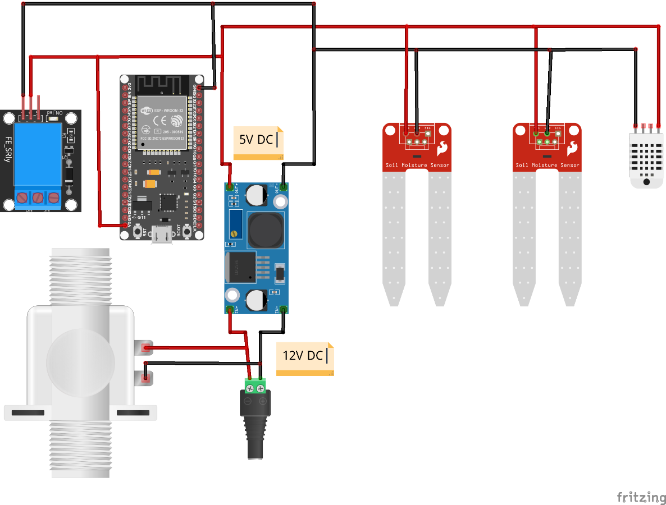

**Application :**

Smart water management using IoT in an ESP32 processor application involves leveraging the capabilities of the ESP32 microcontroller to monitor, control, and optimize water usage in various scenarios. Here's a short overview of the application:

* Water Quality Monitoring: The ESP32 can be equipped with water quality sensors to measure parameters like pH, turbidity, and contamination levels in real-time. This data can be sent to a central server or displayed on a local dashboard for analysis.
* Water Flow Monitoring: Utilize flow sensors or flow meters to measure the rate of water consumption or water flow in pipes. This information helps in identifying leaks, abnormal usage, or unauthorized access to water sources.
* Remote Control: Use the ESP32 to control water valves or pumps remotely based on the data collected. For instance, you can remotely shut off the water supply in case of a leak or control irrigation systems based on weather conditions.
* Data Logging: Store historical data on water consumption, quality, and flow rates for future analysis and trend prediction. This data can be valuable for making informed decisions and optimizing water usage.
* Alerts and Notifications: Implement a notification system that sends alerts via email, SMS, or mobile apps in case of abnormal water usage, leaks, or other critical events. This helps in timely response and preventive measures.
* Integration with Weather Data: Integrate weather forecasts and data into the system to optimize irrigation and water supply based on upcoming weather conditions, reducing water wastage.
* Mobile App and Web Interface: Develop a user-friendly mobile app and web interface that allows users to monitor water usage, control devices, and receive notifications remotely.
* Energy Efficiency: Implement power-saving features in the ESP32 application to ensure the device operates efficiently and can run on battery power for extended periods if needed.
* Cloud Integration: Upload data to cloud platforms like AWS, Azure, or Google Cloud for scalability, data storage, and advanced analytics.
* Sustainability: Use the collected data to encourage water conservation and sustainable practices by providing users with insights into their water usage patterns and encouraging responsible water management.

Smart water management using IoT in an ESP32 processor application can be customized to various use cases, including home water monitoring, agriculture, industrial applications, and more, contributing to water conservation and efficient resource utilization.